Title of Full Paper Formatted as Arial Narrow 26pt bold Name the File as Reference No_Given name_Family name (eg. GS01-01_John_Doe)
Givenname Familyname^{1,*}, Second Author² and Third Author³
1 Affiliation 1; Please write affiliations of the authors Times New Roman 7.5pt, i.e. department, institution, city, country
2 Affiliation 2; Please write affiliations of the authors Times New Roman 7.5pt, i.e. department, institution, city, country
3 Department of Finemechanics, Tohoku University, Sendai, Japan
*Corresponding Author: email@address.com

Abstract:
Please provide an abstract of 150 words. Abstract should be written in English: Times New Roman 9pt. Abstract should be formatted according to this template. The abstract should not contain any undefined abbreviations or unspecified references. Please write your abstract here. Please write your abstract here. Please write your abstract here. Please write your abstract here. Please write your abstract here. Please write your abstract here. Please write your abstract here. Please write your abstract here. Please write your abstract here. Please write your abstract here. Please write your abstract here. Please write your abstract here. Please write your abstract here. Please write your abstract here. Please write your abstract here. Please write your abstract here. Please write your abstract here. Please write your abstract here. Please write your abstract here. Please write your abstract here. Please write your abstract here. Please write your abstract here.
Keywords : Arial Narrow 9pt, Write 3 keywords, Keywords written in English
1. Introduction (Times New Roman 12pt bold)

Contents of the journal should be written in English using Times New Roman 9pt. This sentence is an example please write contents formatted according to this template. Contents of the journal should be written in English using Times New Roman 9pt. This sentence is an example please write contents formatted according to this template. Contents of the journal should be written in English using Times New Roman 9pt. This sentence is an example please write contents formatted according to this template. Contents of the journal should be written in English using Times New Roman 9pt. This sentence is an example please write contents formatted according to this template. Contents of the journal should be written in English using Times New Roman 9pt. This sentence is an example please write contents formatted according to this template. Contents of the journal should be written in English using Times New Roman 9pt. This sentence is an example please write contents formatted according to this template. Contents of the journal should be written in English using Times New Roman 9pt. This sentence is an example please write contents formatted according to this template. Contents of the journal should be written in English using Times New Roman 9pt. This sentence is an example please write contents formatted according to this template. Contents of the journal should be written in English using Times New Roman 9pt. This sentence is an example please write contents formatted according to this template. Contents of the journal should be written in English using Times New Roman 9pt. This sentence is an example please write contents formatted according to this template. Contents of the journal should be written in English using Times New Roman 9pt. This sentence is an example please write contents formatted according to this template. Contents of the journal should be written in English using Times New Roman 9pt. This sentence is an example please write contents formatted according to this template. Contents of the journal should be written in English using Times New Roman 9pt. This sentence is an example please write contents formatted according to this template. Contents of the journal should be written in English using Times New Roman 9pt. This sentence is an example please write contents formatted according to this template. Contents of the journal should be written in English using Times New Roman 9pt. This sentence is an example please write contents formatted according to this template. Contents of the journal should be written in English using Times New Roman 9pt. This sentence is an example please write contents formatted according to this template. Contents of the journal should be written in English using Times New Roman 9pt. This sentence is an example please write contents formatted according to this template. Contents of the journal should be written in English using Times New Roman 9pt. This sentence is an example please write contents formatted according to this template. Contents of the journal should be written in English using Times New Roman 9pt. This sentence is an example please write contents formatted according to this template. Contents of the journal should be written in English using Times New Roman 9pt. This sentence is an example please write contents formatted according to this template. Contents of the journal should be written in English using Times New Roman 9pt. This sentence is an example please write contents formatted according to this template. Contents of the journal should be written in English using Times New Roman 9pt. This sentence is an example please write contents formatted according to this template.

2. Principle (Times New Roman 12pt bold)

2.1 Tables and figures (Times New Roman 10pt bold)
Please check that all illustrations are clear and the lines in line drawings are not interrupted and have a constant width. All tables and figures are to be numbered using Arabic numerals and they should always be cited in text in consecutive numerical order. Captions begin with the term Table and Fig. followed by the corresponding numberings. Figure parts should be denoted by lowercase letters (a, b, c, etc.), i.e., Fig. 1(a) and Table 1. Please refer to figures and tables used in this manuscript.

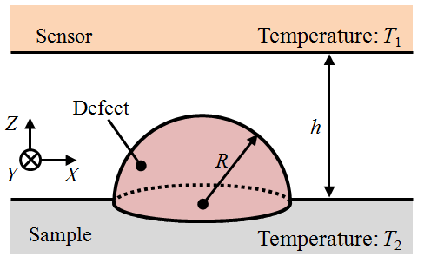
(a)

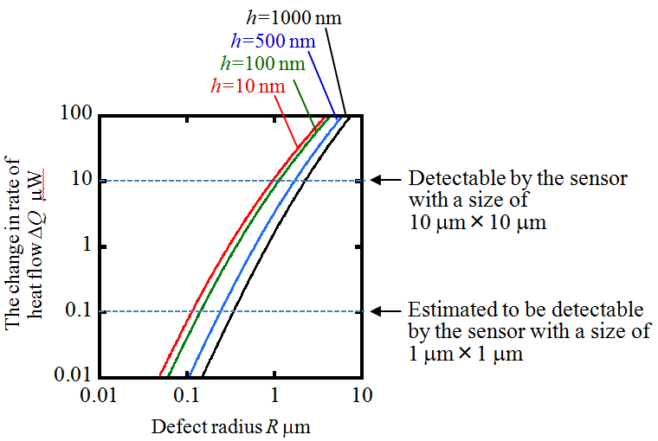
(b)

Fig. 1 An example figure referred from Shimizu Y, et al (2018). Nanomanuf Metrol 1:45-57. (a) A model of defect on a target surface, (b) Estimated DQ with the defect having a radius R
Table 1 An example table
Item | Value
Contents 1 | 683 nm
Contents 2 | 0.8 mm
Contents 3 | 25 mm
Contents 4 | 10 μm

2.2 Equations (Times New Roman 10pt bold)
Please insert equations formatted according to this template. All equations are to be numbered consecutively in brackets. Equations should be written with an equation number in parentheses flush with the right margin, as in Eq. (1). This is an example:
, | (1)
the text following an equation need not be a new paragraph. All variables and symbols used in equations must be described clearly in the text.
(2)
(3)

2.3 References (Times New Roman 10pt bold)
Please make sure that all your sources are correctly listed in the reference section. Reference citations in the text should be identified by numbers in square brackets, i.e., please give citations [1], [2], [1-3], etc. References must be numbered in order of appearance in the text (including citations in tables and legends) and listed individually at the end of the manuscript. The list of references should only include works that are cited in the text and that have been published or accepted for publication. Personal communications and unpublished works should only be mentioned in the text. Please refer to the example references listed at the end of this template.

3. Experiments (Times New Roman 12pt bold)

3.1 Contents (Times New Roman 10pt bold)
Contents of the journal should be written in English using Times New Roman 9pt. This sentence is an example please write contents formatted according to this template. Contents of the journal should be written in English using Times New Roman 9pt. This sentence is an example please write contents formatted according to this template. Contents of the journal should be written in English using Times New Roman 9pt. This sentence is an example please write contents formatted according to this template. Contents of the journal should be written in English using Times New Roman 9pt. This sentence is an example please write contents formatted according to this template. Contents of the journal should be written in English using Times New Roman 9pt. This sentence is an example please write contents formatted according to this template.

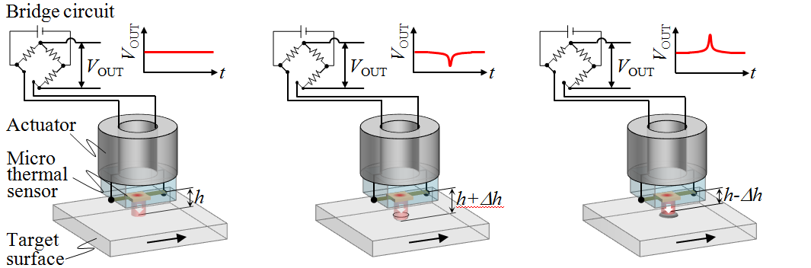
(a) (b) (c)
Fig. 2 An example figure for large size referred from Shimizu Y, et al (2018). Nanomanuf Metrol 1:45-57. (a) An example 1, (b) An example 2, (c) An example 3

Contents of the journal should be written in English using Times New Roman 9pt. This sentence is an example please write contents formatted according to this template. Contents of the journal should be written in English using Times New Roman 9pt. This sentence is an example please write contents formatted according to this template. Contents of the journal should be written in English using Times New Roman 9pt. This sentence is an example please write contents formatted according to this template. Contents of the journal should be written in English using Times New Roman 9pt. This sentence is an example please write contents formatted according to this template.

3.2 Contents (Times New Roman 10pt bold)
Contents of the journal should be written in English using Times New Roman 9pt. This sentence is an example please write contents formatted according to this template. Contents of the journal should be written in English using Times New Roman 9pt. This sentence is an example please write contents formatted according to this template. Contents of the journal should be written in English using Times New Roman 9pt. This sentence is an example please write contents formatted according to this template. Contents of the journal should be written in English using Times New Roman 9pt. This sentence is an example please write contents formatted according to this template. Contents of the journal should be written in English using Times New Roman 9pt. This sentence is an example please write contents formatted according to this template. Contents of the journal should be written in English using Times New Roman 9pt. This sentence is an example please write contents formatted according to this template. Contents of the journal should be written in English using Times New Roman 9pt. This sentence is an example please write contents formatted according to this template. Contents of the journal should be written in English using Times New Roman 9pt. This sentence is an example please write contents formatted according to this template.

3.3 Contents (Times New Roman 10pt bold)
Contents of the journal should be written in English using Times New Roman 9pt. This sentence is an example please write contents formatted according to this template. Contents of the journal should be written in English using Times New Roman 9pt. This sentence is an example please write contents formatted according to this template. Contents of the journal should be written in English using Times New Roman 9pt. This sentence is an example please write contents formatted according to this template. Contents of the journal should be written in English using Times New Roman 9pt. This sentence is an example please write contents formatted according to this template. Contents of the journal should be written in English using Times New Roman 9pt. This sentence is an example please write contents formatted according to this template. Contents of the journal should be written in English using Times New Roman 9pt. This sentence is an example please write contents formatted according to this template. Contents of the journal should be written in English using Times New Roman 9pt. This sentence is an example please write contents

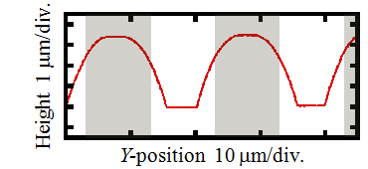
(a)

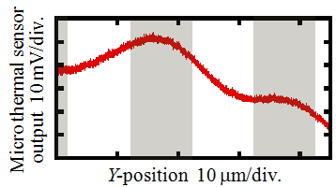
(b)

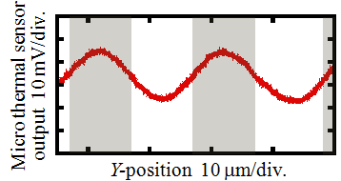
(c)

Fig. 3 An example figure referred from Shimizu Y, et al (2018). Nanomanuf Metrol 1:45-57. (a) An example 1, (b) An example 2, (c) An example 3
formatted according to this template. Contents of the journal should be written in English using Times New Roman 9pt. This sentence is an example please write contents formatted according to this template.

4. Conclusion (Times New Roman 12pt bold)

Contents of the journal should be written in English using Times New Roman 9pt. This sentence is an example please write contents formatted according to this template. Contents of the journal should be written in English using Times New Roman 9pt. This sentence is an example please write contents formatted according to this template. Contents of the journal should be written in English using Times New Roman 9pt. This sentence is an example please write contents formatted according to this template. Contents of the journal should be written in English using Times New Roman 9pt. This sentence is an example please write contents formatted according to this template. Contents of the journal should be written in English using Times New Roman 9pt. Contents of the journal should be written in English using Times New Roman 9pt. This sentence is an example please write contents formatted according to this template. Contents of the journal should be written in English using Times New Roman 9pt. This sentence is an example please write contents formatted according to this template. Contents of the journal should be written in English using Times New Roman 9pt. This sentence is an example please write contents formatted according to this template. Contents of the journal should be written in English using Times New Roman 9pt. This sentence is an example please write contents formatted according to this template. Contents of the journal should be written in English using Times New Roman 9pt. This sentence is an example please write contents formatted according to this template. Contents of the journal should be written in English using Times New Roman 9pt.

ACKNOWLEDGEMENT

Contents of the journal should be written in English using Times New Roman 9pt. This sentence is an example please write contents formatted according to this template. Contents of the journal should be written in English using Times New Roman 9pt.

REFERENCES

- Marchon B, Olson T (2009) Magnetic spacing trends: From LMR to PMR and beyond. IEEE Trans Magn 45:3608–3611.
- May GS, Sze SM (2004) Fundamentals of Semiconductor Fabrication. Wiley, New York.
- Tsai DM, Luo JY (2011) Mean Shift-Based Defect Detection in Multicrystalline Solar Wafer Surfaces. IEEE Transactions on Industrial Informatics 7:1:125-135.
- Brinksmeier E, Mutlugünes Y, Klocke Aurich JC Shore P, Ohmori H (2010) Ultra-precision grinding. CIRP Ann Manuf Techn 59:2:652-671.
- International Roadmap for Devices and Systems 2016 Edition. https://irds.ieee.org/. accessed 29 November 2017.
- David CD, B´ech´e A, Rouvi`ere JL, Servanton G, Pantel R, Morin P, Chabli A (2011) Field mapping of semiconductors in a state-of-the-art electron microscope. AIP Conf Proc 1395:64–73.
- Lonardo PM (1991) Surface Characterization and Defect Detection by Analysis of Images Obtained with Coherent Light. CIRP Ann Manuf Techn 40:1: 541-544.
- Takami K (1997) Defect inspection of wafers by laser scattering. Mat Sci Eng B-Solid 44:181-187.
- Young AT (1981) Rayleigh scattering. Appl Opt 20:4:533-535.
- Attota R, Silver R (2011) Nanometrology using a through-focus scanning optical microscopy method. Meas Sci Technol 22:024002.
- Takahashi S, Kudo R, Usuki S, Takamasu K (2011) Super resolution optical measurements of nanodefects on Si wafer surface using infrared standing evanescent wave. CIRP Ann Manuf Techn 60:1:523–526.
- Shimizu Y, Lu W, Ohba Y, Gao W (2014) Feasibility study on the concept of thermal contact sensor for nanometre-level defect inspections on smooth surfaces. Meas Sci Technol 25:064006.
- Shimizu Y, Xu J, Kohira H, Kurita M, Shiramatsu T, Furukawa M (2011) Nano-Scale Defect Mapping on a Magnetic Disk Surface Using a Contact Sensor. IEEE Trans Magn 47:10:3426-3432.
- Shimizu Y. Matsuno Y, Chen YL, Gao W (2017) Design and testing of a micro thermal sensor for non-contact surface defect detection. Int J Autom Techn 11:5:781-786.
- Martinek J, Valtr M, Cimrman R, Klapetek P (2014) Thermal conductivity analysis of delaminated thin films by scanning thermal microscopy. Meas Sci Technol 25: 044022.
- Gomès S, Newby P, Canut B, Termentzidis K, Marty O, Fréchette L, Chantrenne P, Aimez V, Bluet JM, Lysenko V (2013) Characterization of the thermal conductivity of insulating thin films by scanning thermal microscopy. Microelectr J 44:11:1029–1034.
- Lantz MA, Binnig GK, Despont D, Drechsler U (2005) A micromechanical thermal displacement sensor with nanometre resolution. Nanotechnol 16:1089–1094.
- Zhang S, Bogy DB (1999) A heat model for thermal fluctuations in a thin slider/disk air bearing. Int J Heat Mass Transfer 42:1791-1800.
- Wen X, Traverso LM, Srisungsitthisunti P, Xu X, Moon EE (2013) High precision dynamic alignment and gap control for optical near-field nanolithography. J Vacuum Sci Technol B 31:041601.
- Ennos AE, Virdee MS (1982) High accuracy profile measurement of quasi-conical mirror surfaces by laser autocollimation. Precis Eng 4:1:5-8.
- Gao W (2010) Precision Nanometrology -Sensors and Measuring Systems for Nanomanufacturing. Springer, London.

